JOIN MYSQL

select nama_obat, category_name, satuan, stok, harga

from obat as o

join kategori as k

on o.category_id = k.category_id

where stok > 5

order by stok

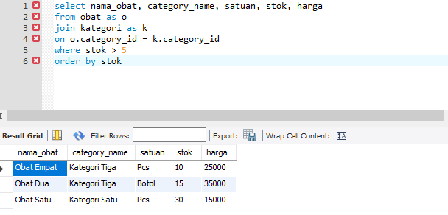

Select pd.id_transaksi, count(jmlh_obat) as banyak_jumlah_obat,

p.tgl_transaksi, sum(harga) as total

from penjualan_detail as pd

join penjualan as p

on pd.id_transaksi = p.id_transaksi

group by id_transaksi

order by total desc

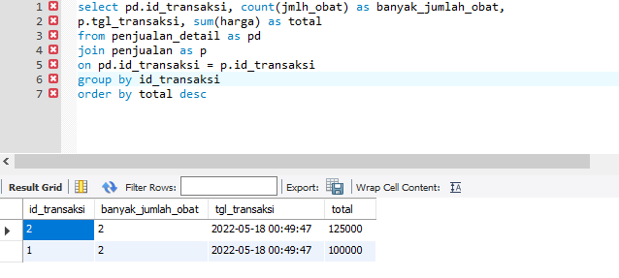

select o.id_obat, o.nama_obat, k.category_name, satuan, stok, harga

from obat as o

right join kategori as k

on o.category_id = k.category_id

where k.category_name LIKE "%tiga"

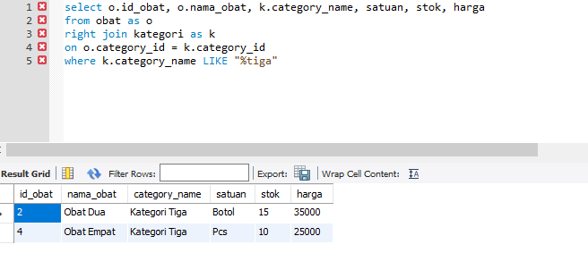

select o.id_obat, o.nama_obat, k.category_name, satuan, stok, harga

from obat as o

right join kategori as k

on o.category_id = k.category_id

where o.id_obat IS NULL

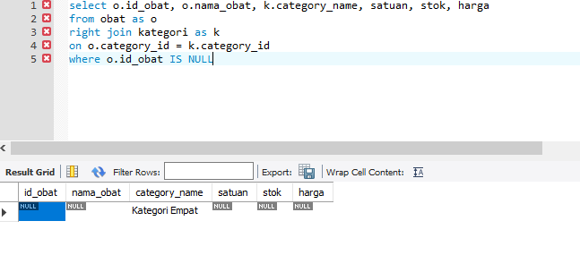

select o.id_obat, o.nama_obat, k.category_name, satuan, stok, harga

from obat as o

left join kategori as k

on o.category_id = k.category_id

where stok > 5

order by harga desc

